FA Commands

FA Commands
制作： | 制作时间： | 审核： | 审核时间：
Bradley | 2017-11-15 | Jim | 2017-11-16

版本
版本名称 | 修改人 | 修改项 | 修订时间 | 备注
V1.0 | Bradley | Format modification | 2017-11-16

目录

- Iboot mode commands
- OS mode commands
- Diags mode commands
- Panic station commands
- Station commands
- Other commands

1.iboot mode commands
1.printenv: Print the environment variate
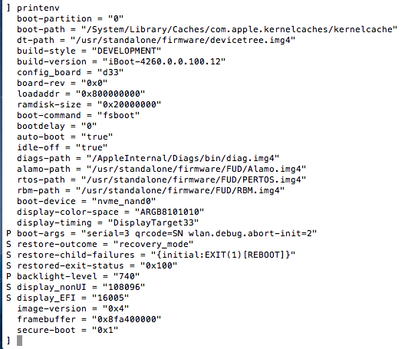
2.setenv: Set the environment variate
3.saveenv: Save the environment variate
4.reboot: Reset the decive
5.poweroff: shut down the device
6.fsboot: Enter OS mode
7.diags: Enter diag mode

2.OS mode commands
1.nvram –p: Print current nvram value.
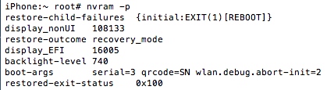

2.nvram #env=”#value”
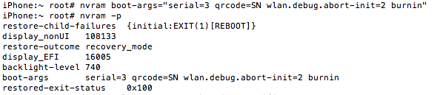
3. diagstool bootargs –print: Print current boot-args
diagstool bootargs –-add or –-a [arg]: Add the boot-arg given as the argument
diagstool bootargs --remove or –-r [arg]: Remove the boot-arg given as the argument if it exists
diagstool versions –osdroot: Print OS Diags Root Version.
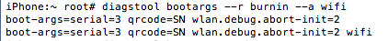
3.launchctl list: List information about services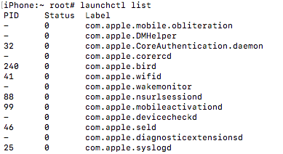
4.launchctl unload #service.plist: To unload a service
5.launchctl load #service.plist: To load a service
6.gestalt_query –listKeys: List related to info of unit
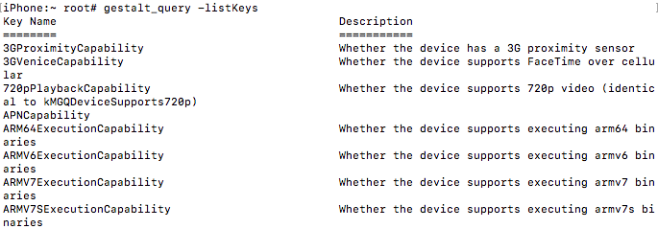
7.gestalt_query SerialNumber: Get unit SN
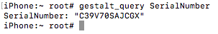
8. mobdev pair: Create new pairing records with the device
modev list: List all have been detected devices
mobdev get NULL NULL: Lists device related properties useful for debugging.
mobdev is_paired: Check to see whether or not this host machine is paired with the device.
mobdev unpair: Remove pairing records on both host and device.

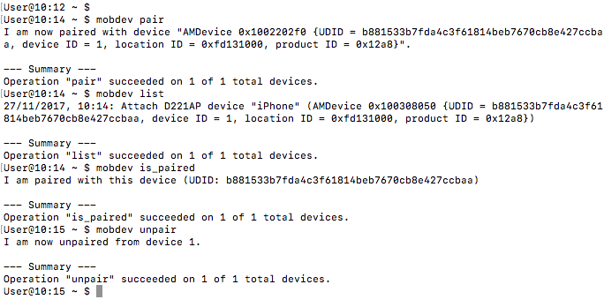
10.ls –al: List contents in current path
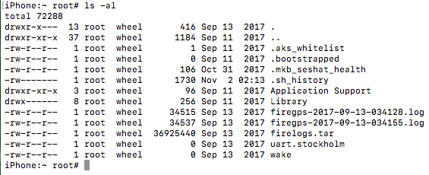
11.ps –ajx: Check process status
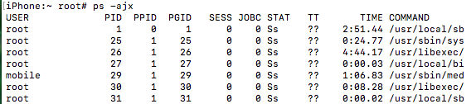
12.top: Check process used
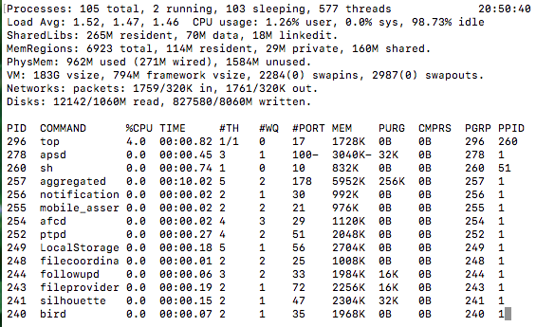
13.df –h: Check disk used
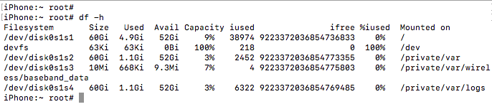
14.du –s –h *: Check size of contents
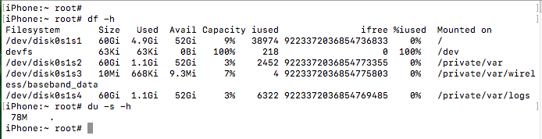
15. mkdir [-pv] [-m mode] directory: Create directory
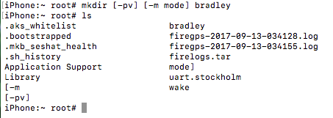
16.enter_kdb: make unit panic
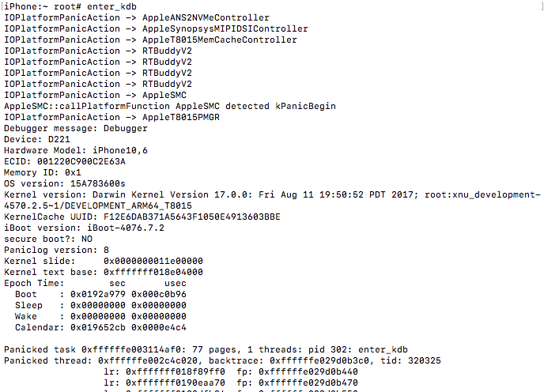
17.cd # file path: Enter file path
18.ls： List all file in current path
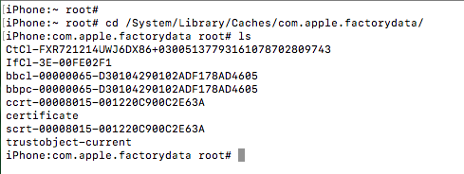
19.sw_ver: Check the unit OS version
20.pwd: Show current path
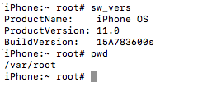

22.sysdiagnose: gathers unit sysdiagnose
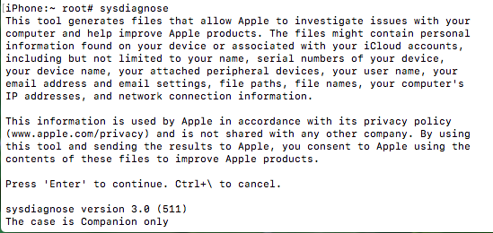
23.reboot: restart the unit
24. controlbits –h --help: help with controlbits command
25. controlbits init: Initialize control bits area
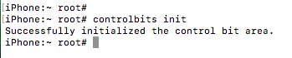
26. controlbits read: Read control bits
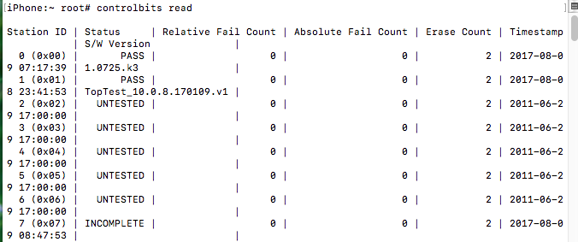
27. controlbits write: Write control bits
28. controlbits erase: Erase control bits
29. controlbits info: Print information about station ID and station name
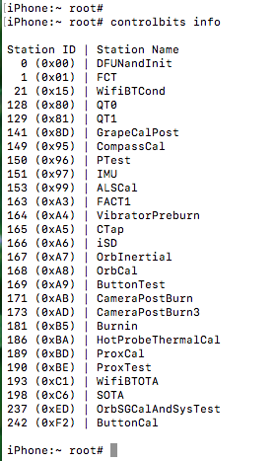
30. controlbits –version: Show controlbits version
31.ioreg: check the information of all chips on the device
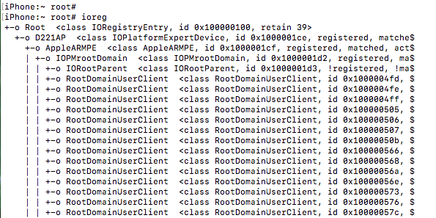
31.ioreg –l: list properties of all objects
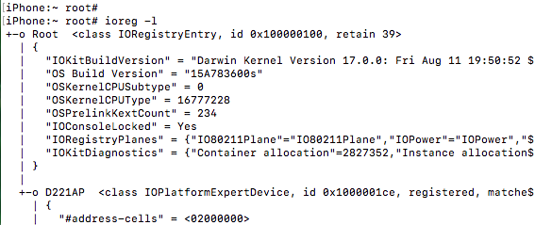
32. setbatt: read raw battery voltage
Setbatt on: set battery charge
33. setbright : set screen bright
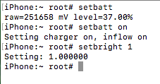
34. diagstool hwmisc --displayPower : Sets the display's power.
35. diagstool hwmisc –displayBrightness: Sets the display's brightness. [0 1] 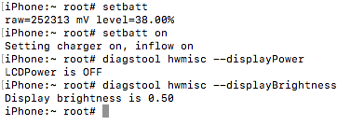
36. sysconfig read: Read sysconfig keys
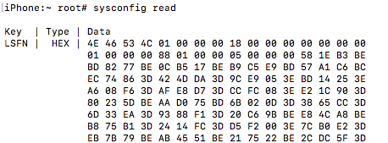

37. sysconfig write --key KEY --value VALUE: Write sysconfig keys
38. sysconfig delete --key KEY: Delete sysconfig keys
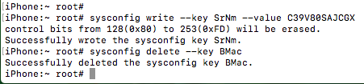
39. sysconfig info: Print sysconfig specifications
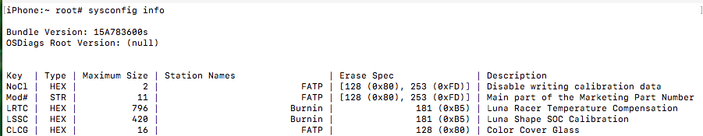
40.find / -iname “key or file”: find the key or file
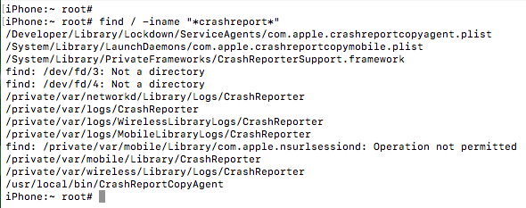
41. FactoryServicesHost –u localtionID --run or –r ‘path of binary on device with arguments’
43: log stream: watch live system logs
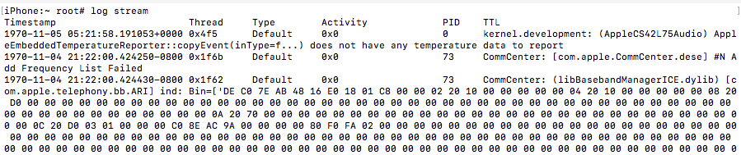
44. log show: view/search system logs
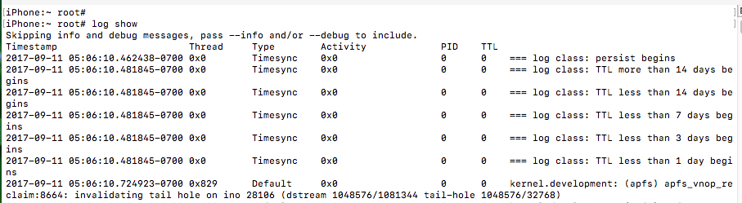
46.halt: shut down the device
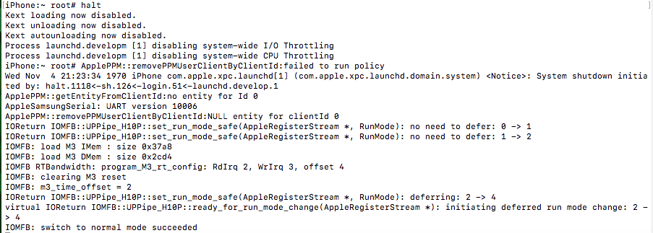
47. tcprelay --portoffset 10000 873 23 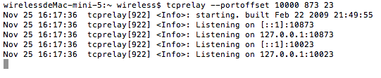telnet localhost 10023:Mask terminal information
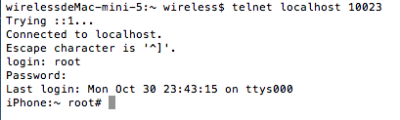
48. copyUnrestricted –u 0x1d111000 –s /root/private/var/logs –t /User/gdadmin/Desktop
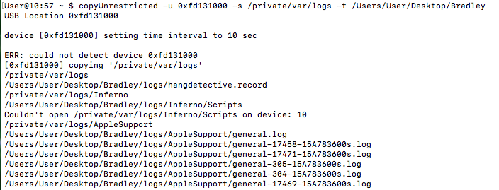
49. log stream --system --style syslog :show device system log
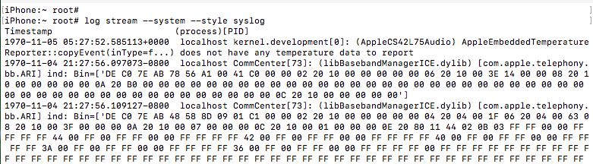

3.diags mode commands
1.nvram --l: list nvram key
2.nvram –-set #env #value:
3.nvram --save :set and save the nvram value
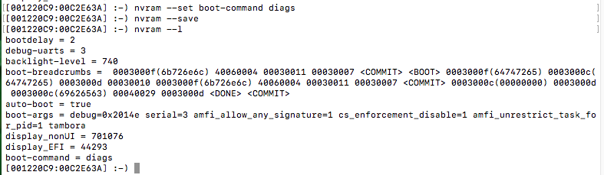
4.syscfg list:the list of system config key and value
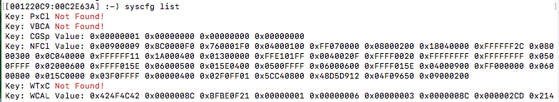
5.syscfg add Regn LL/A: modify value of a key
6.syscfg delete: delete a key
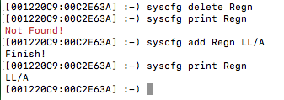
7.cbreadall: read all control bits
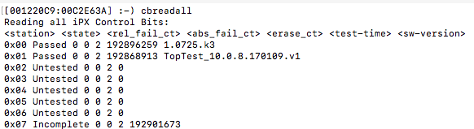
8.cbinit: initialize control bit area
9.cberas 0xCF:eras a control bits
10.cbread 0xCF: read a control bits
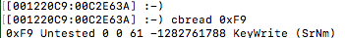

11. dev –k gasgauge –p: Check the battery information
charge --set 1000 –force: Force the charging current to be 1000ma
bl –p 2%: set the screen brightness of the device
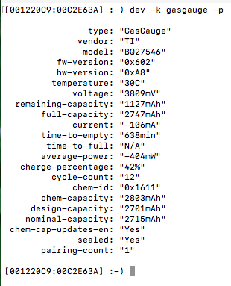
12. dir nandfs:\System\Library\Caches\com.apple.factorydata
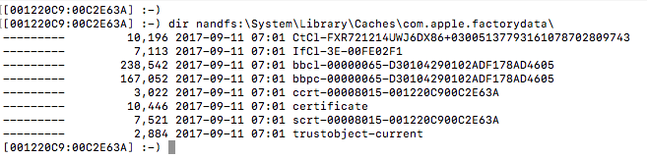
13.baseband –-collect_coredumps:To collect coredump if command fail at diags mode
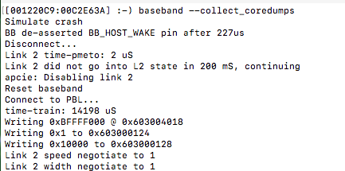
14.baseband –-on –-load: load baseband firmware
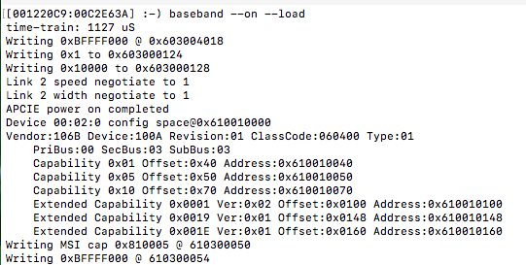
15. baseband –p : print baseband info
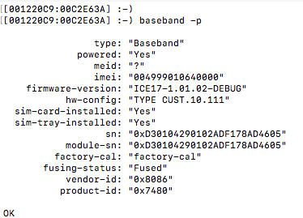
16. soc –p: print soc info
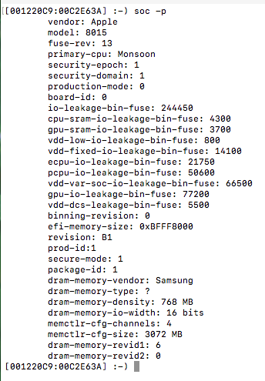
17.display –-on: Light up the screen
18.display --off: Close the screen
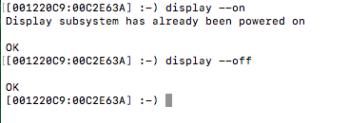
19 bl –n:Test BackLight normal
-o: Test Switch off backlight
-l: Test BackLight low level
-m: Test BackLight medium level
-h: Test BackLight high level
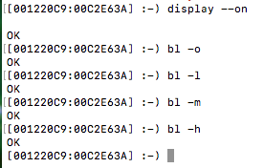
20. camisp –-find: find all the sensors(camera) in the system
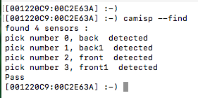
18.nandsize: Check device nand size
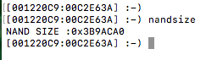
19.reset: reset the device
20. sensor –-getinfo: Lists information about the various parameters exported by each sensor and their usage
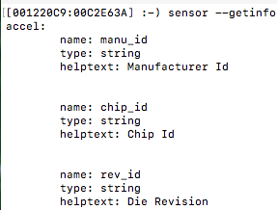
21. version: Check the device diag version
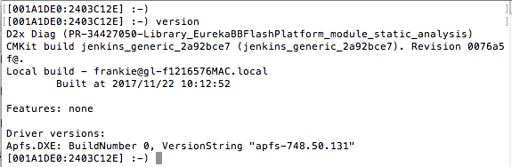
22. cat nandfs:\System\Library\CoreServices\SystemVersion.plist: Check os version in diags mode
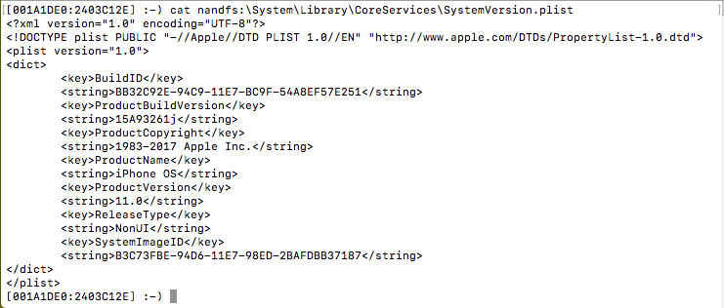
23. usbfs –f <target path>: Mounting folder path over USB to diags

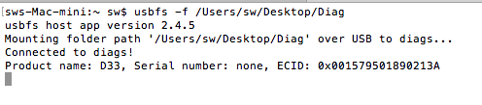
24.usbfs --mount :
cp -r nandfs:\System\Library\Caches\com.apple.factorydata\ usbfs:\ : Copy the device folder into have been mounted folder.
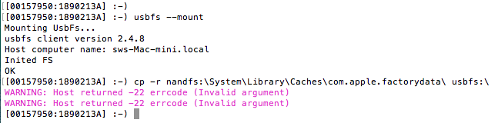

4. Panic station commands
- marvin factory: capture core file automatically
- astrisctl isPanic; Check if panic state
- astris; Check if respond
- astrisctl fwupdate /Users/gdlocal/Desktop/kanzi-0062.bin : update kanzicable version
- coredump; Collect core file
- co_dump –cpu AOP #filename: Collect AOP core file
- co_dump –cpu SIO #filename: Collect SIO core file
- halt –cpu all: halt cpu state
- go –cpu all; go cpu state
- jebdump; Collect jebdump file
jebdump #filename:
- astris –enable-jtagap=false
enable_swd_bypass-force_pins 2
halt –cpu all
s4_coredump #filename : Collect S4E file

5：Station commands
- factory_purple_restore –l (locationID) –D (#encrypt PR file): restore by command.
- factory_purple_restore: encrypt PR_file
- purple_restore: decrypt PR
- factory_demo_restore –l (locationID) –D (#demo bundle file): Restore demo bundle to device.
- personalized_image_mounter –p image file –V FactoryDiskImage –c –U http://spidercab:8080 –u (#UDID): mount FDI
- image file path://Volumes/HedgehogRepo/Live/default/FactoryDiskImagePersonalized.dmg
- FactorySupportUtil –l (#UDID) –k (listKeys): get device info
- fdr_client put -k ShMC -u 123 -d https://fdrds.apple.com:8443 -a https://fdruca.apple.com:8443 -U http://fdruca.apple.com:8080/fdrtrustobject -i ./ShMC-123 -p 'GET/ShMC:*;PUT/ShMC:*': put FDR data to server
- fdr_client get -f -d https://fdrds.apple.com:8443 -a https://fdruca.apple.com:8443 -s https://fdruss.apple.com:8443 -U http://fdruca.apple.com:8080/fdrtrustobject -k ShMC -u 123 -o ShMC-123: get FDR data from server
- logdump –archvice #logarchvice file: open logarchvice file
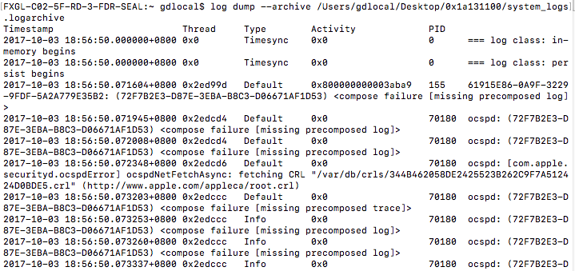
- cat or plutil –p file: open the file
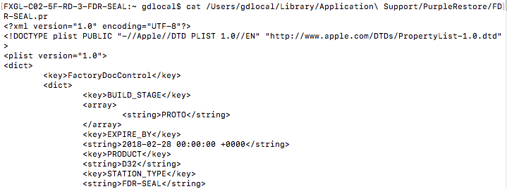
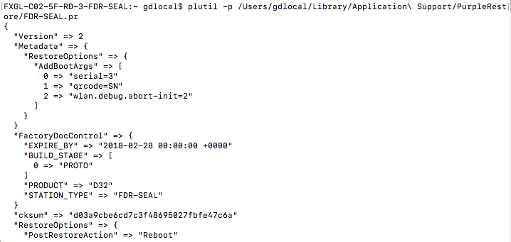
- copyUnrestricted -w -u 0x2410000 -s target file -t unit –t: To copy target file to device
- FactorySupportUtil –u UDID –l: list all supported keys (device in OS mode)
- FactorySupportUtil –u UDID –k #keys: key to query
- tar –vxf: open txz file(Earthbound file)
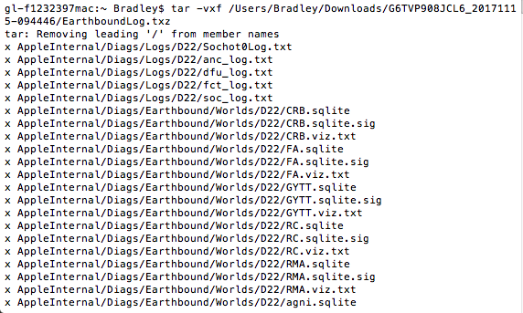
- base64 –i encrypt file –o new file –D: decrypt file
- artivate -v -d -F -A "http://activation:8080/raptor/processor" -a "http://activation:8080/raptor/processor" -l localtionID pkgutil –-expand file finder: Manual activate UI interface command
- gunzip -dc Payload cpio | -i: decrypt PR tool
- history: List all use command
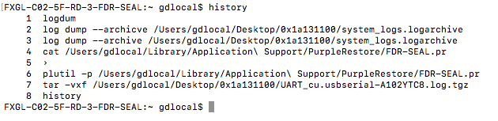

- ifconfig en0: show network and mac address
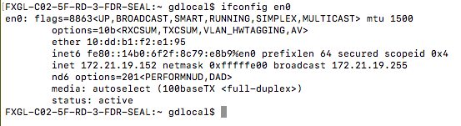
- link source_file target_file: link file
- mount -t nfs "OVERLAY_SOURCE" finder: mount overlay on mac
- nanokdp: Connect device with terminal
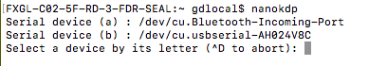
- nanocom: Connect device with terminal at panic station
- ping URL: send ICMP ECHO_REQUEST packets to network hosts
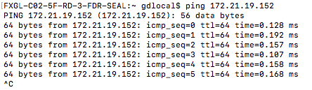
- chmod 777 file: change file access
- rm file: remove file
- rm –rf file: force remove file
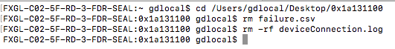
- su :replace user identity
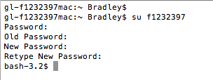
- sudo: execute a command as another user
- ssh: OpenSSH SSH client (remote login program)
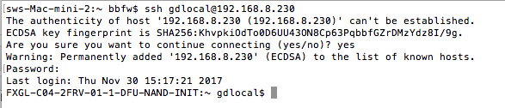
- scp: secure copy (remote file copy program)
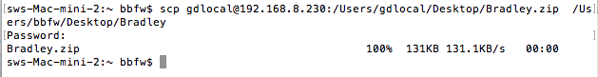
- which: locate a program file in the user's path
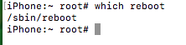
- compress file: compress file
- uncompress file: uncompress file
- md5 file : check file md5 value

6：Other commands
- astris: to check the device cpu status
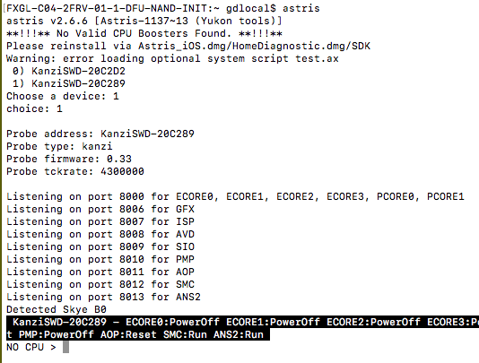
- astrisctl reset: Pulse reset to the target, or hold reset line at the specified level
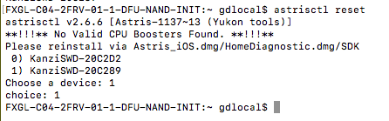
- astrisctl relays: Display values of all probe relays
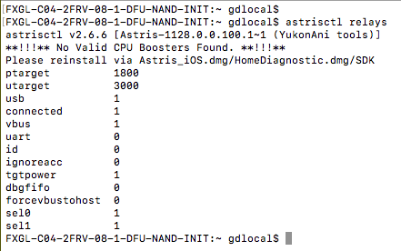
- astrisctl relay vbus 0: To make the kanzicable lost charge function
- astrisctl relay vbus 1: To make the kanzicable have charge function
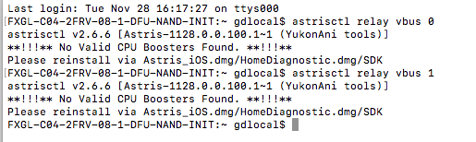
- astrisctl list: List all probes
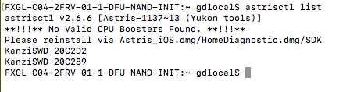
- amfm-bail-ifnoep=1: add this command into boot-args can fix “port enable failed” panic
- baseband-pcie-nolu-panic=0: Add this command into boot-args can fix “Applebaseband” panic
- debug=0x2014e: Add this command into boot-args to auto collect coredump for KPCheck panic with prod-fused unit.
- debug= 0x14e: Add this command into boot-args to auto collect coredump for KPCheck panic with dev-fused unit.
- burnin-size=0: Delete this boot-args to fix “burnin-size should not be set” panic.
- wlan.debug.abort-init=2: Add this command into boot-args can fix “AppleBasebandD20” panic.
- sqlite3 valid_error.sqlite3 "PRAGMA integrity_check": can use this command to test if the DB is corrupted or not.
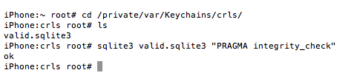
- sudo install/uninstall file: install/uninstall the root file to debug.
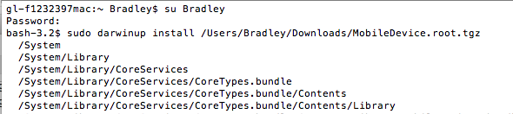
- darwinup list: list the have been install file.
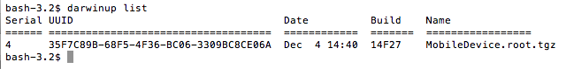
- sample #PID: Profile a process during a time interval
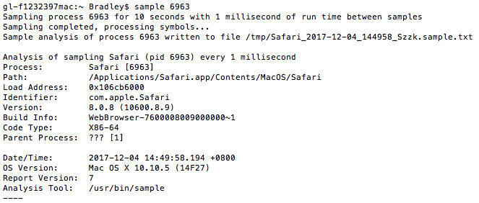
- Remote FDR Data verification success for lcrt-C0D761B8BE366C
In the restore log, you can see following pattern:
At offset 0x98:
we expect to see : 30 82
At offset 0x9c:
we expect to see : 30 82
After 0x300, should be all zero.
